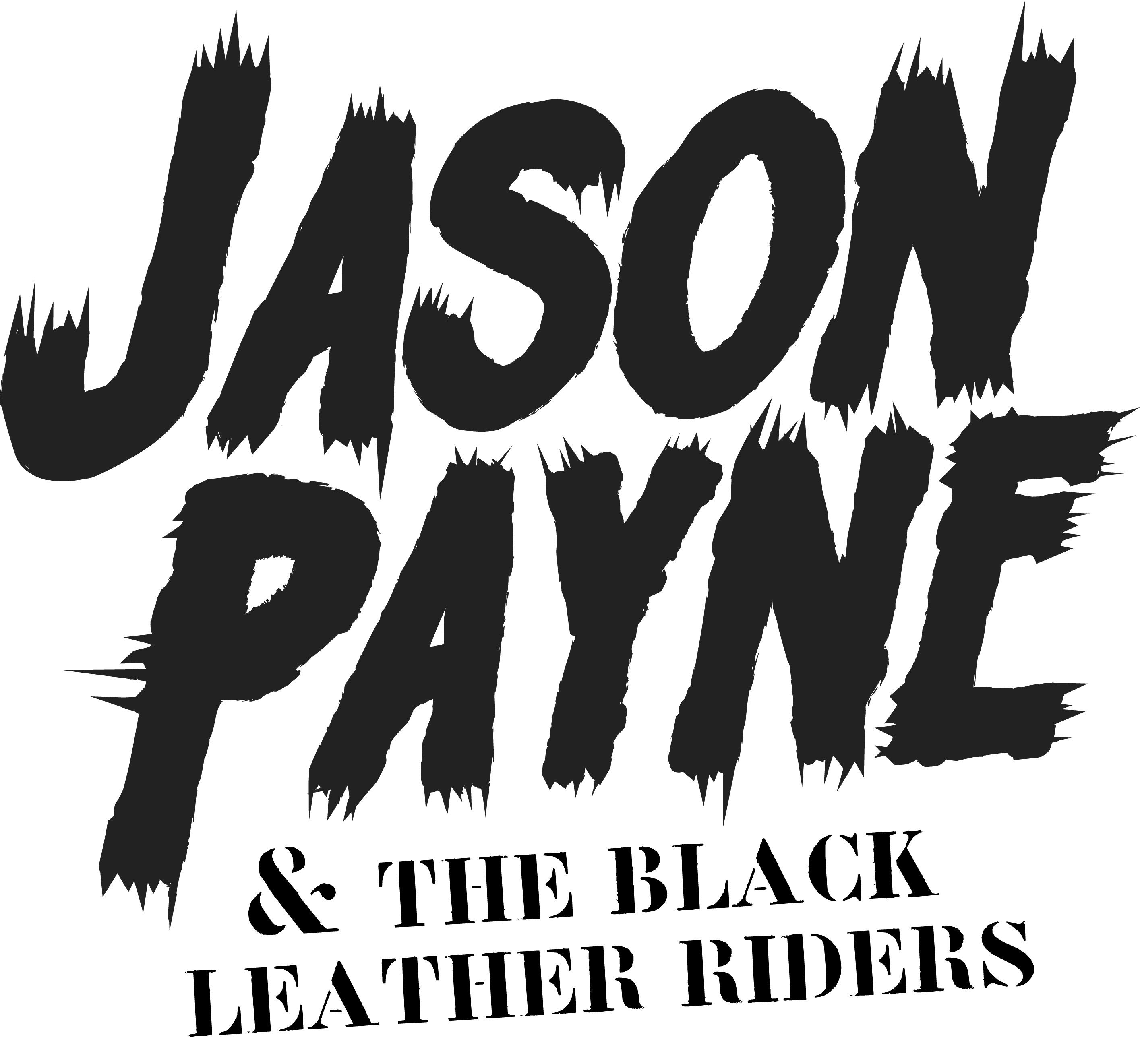

FOR IMMEDIATE RELEASE – 16 JULY 2021

BRITISH METAL NEWCOMERS JASON PAYNE & THE BLACK LEATHER RIDERS INVITE YOU INTO ‘THE ABYSS’ WITH DEBUT EP, AND BRAND NEW VIDEO ‘THE PURGE’.

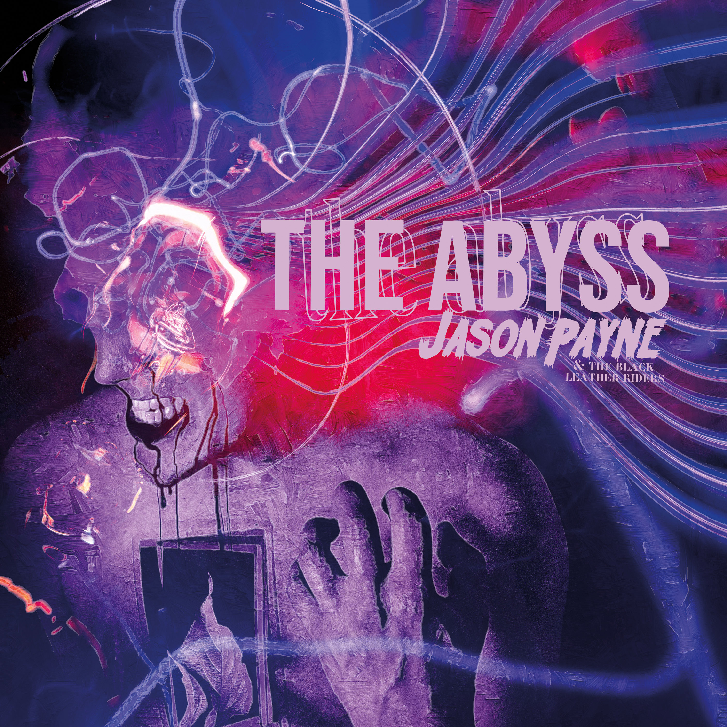

Today, July 16th, London based metallers JASON PAYNE & THE BLACK LEATHER RIDERS release their 6-track debut EP 'The Abyss'. To celebrate the EP, the band has unleashed a video for their latest single 'The Purge'.

Watch 'The Purge' video here: https://youtu.be/tw_KxmTr8xg
Stream the EP ‘The Abyss’ here: www.thejasonpayne.com/listen

Jason on 'The Purge':
"Very proud and excited to release our new video “The Purge”. It’s a song that talks about feeling stuck in your own prison and then you fight your own demons and you set yourself free from the pain. It was inspired by a personal chapter in my life and with the ideology of cleansing yourself from the sins and mistakes you did in the past. It’s about forgiving yourself and move on. A powerful, upbeat, riff-driven, sing-along new single in support of my new EP, with a music video shot in the legendary Camden Town venue 'The Underworld' to accompany."

Jason Payne on the debut EP "The Abyss":
"The Dark is a song that sums up the theme of this EP, "The Abyss". It’s about death, obscurity and the “nothing”. It talks of things like trying to reach to the void, feeling confused and betrayed, and about a person that’s losing his essence. Without a consciousness, and with no purpose in our lives, we’re just a bunch of roamers taking a road to the abyss, and that leads us to the dark and lashes us to insignificant beings floating in “the nothing”.
When I was writing this EP, I got affected by the outside world. It’s a dark period that we’re living. I caught the essence and the feelings that this time put me through and made a whole EP about existentialism and nihilism. This period made me question who am I, what’s my purpose, what have I done with my life and what if this all ends now? Would it matter? Do we matter? Does life matters? Of course, it does! In my opinion, there’s no point of doing anything or living if this doesn’t matter. However, when I wrote this EP, I don’t give you the bright side of the story. That’s for the fans to find out. My whole point with this work is to make people question their lives and feel these emotions. This record means so much to me, since it’s about everything I felt and still feel. I’m a person who never stops asking questions. I always want to know more. Specially, when it comes to existentialism, I’m always in internal conflict, since I question everything. This is my message, this is my music and it’s about how I feel, and hopefully, people will relate to it."

Stream / Buy the EP here: http://smarturl.it/JPtheabyss

'The Abyss' EP Tracklist:
1. The Dark (feat. Daisy Pepper)
2. Breathing Rage (feat. Andy Martongelli)
3. The Purge
4. Vicious
5. Lost
6. Thoughtless

Also watch the EP video teaser here: https://youtu.be/MGdZ6hFFa4c

Jason on 'The Abyss' EP and coverart:
"Writing this EP was a sensational experience for me. Lyrics are very personal and me and the guys put our hearts and soul in making this. It’s the most powerful, boldest and heaviest work we’ve ever done so far. I believe this sets new standards for our future works and I couldn’t be prouder of what we achieved by creating such a unique work of art.
We named it the Abyss due to the dark period of time we’ve been going through, due to the pandemic. However, by diving into an abyss, for us, it doesn’t necessarily mean to hit the ground and die, but to be reborn. If we learn something from life is that every time we have to face a hard path, we have to find a way of overcoming those obstacles. These tracks are full of rage, insanity and introspective moods.
Fall into the glooms of darkness with us."

Recently, the band launched their Patreon fundraising campaign, check it out and support, here: www.patreon.com/thejasonpayne

-----------------

May 20th, the band performed live their earlier single 'The Dark' at Under The Bridge (Chelsea Football Stadium). The band has posted the official live video on their YouTube channel, in case you missed it, watch it here: https://youtu.be/MFeUOF3uCTE

----------------

With a history boasting over half a million streams, 50 live shows and a modest lifetime of musical creation with past acts, London based metal artist Jason Payne took 2020 to embark on a new journey; JASON PAYNE & THE BLACK LEATHER RIDERS. A culmination and reincarnation of his strongest creations, featuring debut single 'Waking The Damned’, plus 'The Dark’, ’The Purge', and numerous other high energy tracks making up the arsenal that is The Abyss, the debut EP out now. Think Slash, Alter Bridge, Metallica, and many other legendary influences. Think big riffs, impactful grit-laden vocals, and an energy just screaming to be invited to the live stage.

Watch the past videos:
'The Dark' official video, here: https://youtu.be/TIENdwGGGgw
'Waking The Damned': https://youtu.be/f_hDsqhQHTQ

----------------

Facebook | Instagram | Twitter | YouTube | www.thejasonpayne.com

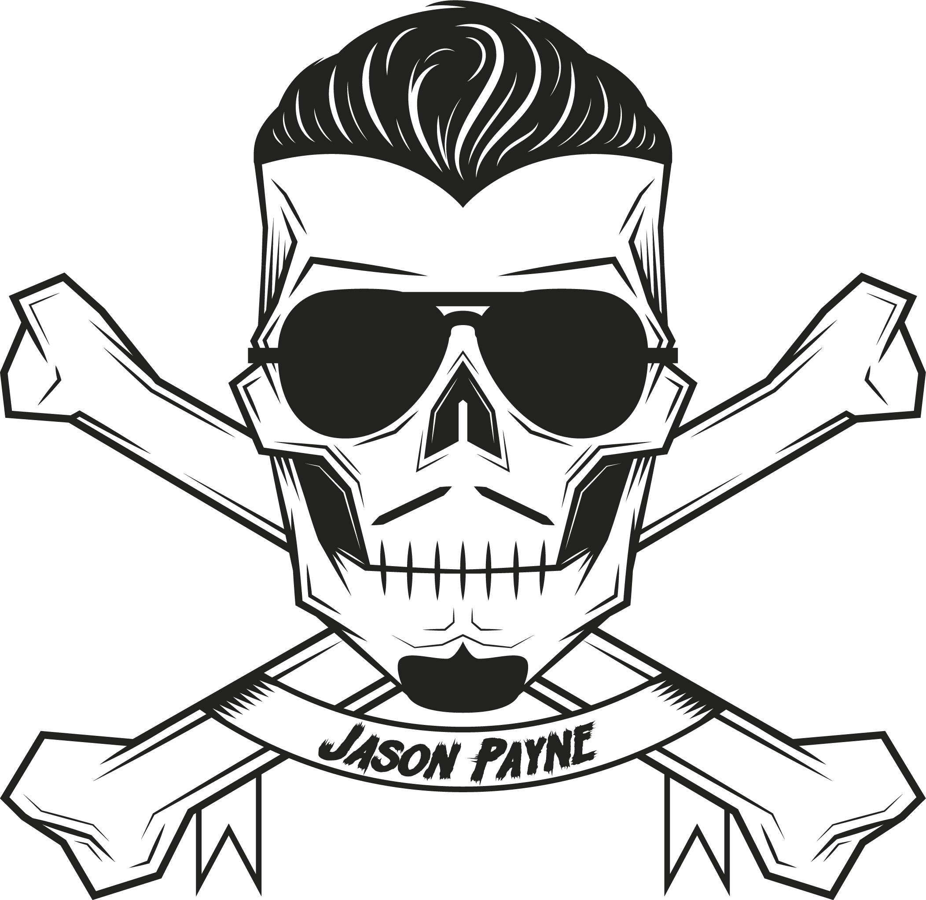

Press & Digital: dan@anaconda-media.co.uk | Band: thejasonpayne@hotmail.com

